|  |  |  |
| --- | --- | --- |
| **S.NO** | **CHAPTER** | **PAGE NO.** |
| 1 | INTRODUCTION |  |
|  | 1.1 SYNOPSIS |  |
|  | 1.2 PROBLEM DEFINITION |  |
|  | 1.3 COMPANY PROFILE |  |
|  | 1.4 PROJECT DESCRIPTION |  |
| 2 | SYSTEM ANALYSIS |  |
|  | 2.1 EXISTING SYSTEM |  |
|  | 2.2 PROPOSED SYSTEM |  |
| 3 | SYSTEM REQUIREMENT |  |
|  | 3.1 HARDWARE REQUIREMENT |  |
|  | 3.2 SOFTWARE REQUIREMENT |  |
|  | 3.3 SOFTWARE DESCRIPTION |  |
| 4 | SYSTEM DESIGN |  |
|  | 4.1 ARCHITECTURE DESIGN |  |
|  | 4.2 DATA FLOW DIAGRAM |  |
|  | 4.3 ER DIAGRAM |  |
|  | 4.4 DATA BASE DESIGN |  |
| 5 | SYSTEM IMPLEMENTATION |  |
| 6 | SYSTEM TESTING |  |
| 7 | SAMPLE INPUT AND OUTPUT |  |
|  | 7.1 SOURCE CODE |  |
|  | 7.2 SCREEN LAYOUT |  |
| 8 | FUTURE ENHANCEMENT |  |
| 9 | CONCLUSION |  |
| 10 | BIBLIOGRAPHY |  |

**1. INTRODUCTION**

**1.1 SYNOPSIS**

With the fast development of cloud services, huge volume of data is shared via cloud computing. Even though cryptographic techniques have been utilized to provide data confidentiality in cloud computing. Data Owner encrypts & uploads the file into the cloud and tags co-owner of the file. Data Co-Owners append access policies and generate renewed cipher text. Data Disseminator gives re-encryption key to disseminate the data if he satisfies enough access policies. Data Accessor decrypts the data by giving his private key. The security analysis scheme is efficient for secure data sharing with multi-owner in cloud computing. In this project we use symmetric key encryption algorithm to encrypt the data before storing into the cloud server.

**1.2 PROBLEM DEFINITION**

It is essential to adopt access control mechanisms to achieve secure data sharing in cloud computing. Currently, cryptographic mechanisms such as attribute-based encryption (ABE), identity-based broadcast encryption (IBBE), and remote attestation have been exploited to settle these security and privacy problems. ABE is one of the new cryptographic mechanisms used in cloud computing to reach secure and fine-grained data sharing. It features a mechanism that enables an access control over encrypted data using access policies and ascribed attributes among decryption keys and cipher texts. Besides the requirement of conditional data dissemination, multiparty access control problem for data sharing in cloud computing such as cloud collaboration and cloud-based social networks comes along, which means the special authorization requirements from multiple associated users can be accommodated together to control the shared data.

**1.3 COMPANY PROFILE**

Phoenix Softech found its beginning in 2001 in madurai and branches in Chennai and kovai is focused on providing IT Strategy Consulting and Technology Solutions across several verticals – Healthcare, Pharmaceuticals, Logistics and other verticals.

The world today Phoenix Softech Limited reflects the cataclysmic environment in which we endeavor new challenges that leaders across the stream are facing include standards of corporate social responsibility, sustainable development, resource and energy efficiency and increasing level of automation. Technology has been advancing at an incredible pace and to keep pace with this change it becomes imperative to have a forum to experiment perspectives in a multicultural atmosphere. The leader of tomorrow has to work within a context that extends far beyond the classic conventional concepts to consider and foretell the jigsaw of relationships across the society and technologies. PHOENIX wants to be a focal point for radiating a quest of innovation and excellence in multicultural atmosphere. Our inception strives to cater to the learning needs of individuals. We recognize the need for vocational education in India.

To accelerate the pace of development emerging economies like India require growth in knowledge based resources rather than material resources. This can be further enhanced by the potential of information technology. We propose to ponder over training and application development skills. Thus our mission is to establish in the academic map of high end training. We are looking forward to having academic collaborations.

**1.4 PROJECT DESCRIPTION**

**MODULES**

* Trusted Authority
* Cloud Service Provider
* Data Owner
* Data Co-Owner
* Data Disseminator
* Data User

**MODULES DESCRIPTION**

**Trusted Authority:-**

The trusted authority is a fully trusted part that initializes the system public key, and generates private keys as well as attribute keys for users. It can be acted by the administrator of the organization or social security administration. Trusted authority is fully trusted by other entities and will not collude with any entities, which is also employed by related works. Trusted authority chooses a security parameter, a maximum number of receivers N, and randomly chooses cryptographic hash functions. The trusted authority generates the private key SK for the user with identity ID. The trusted authority generates the attribute key for data disseminator.

**Cloud Service Provider:-**

The CSP is a semi-trusted part that provides each user with a virtual space and convenient data storage service with the cloud infrastructure. It also appends access policies to the cipher texts for data co-owners and generates re-encrypted cipher texts for users. The data should be well protected against the semi-trusted CSP and unauthorized users. The users who are not the receivers of a cipher text defined by the data owner or data disseminator should not be able to access the plaintext.

**Data Owner:-**

The data owner can choose a policy aggregation strategy and define an access policy to enforce dissemination conditions. Then he encrypts data for a set of receivers, and outsources the cipher text to CSP for sharing and dissemination. The data owner can customize fine-grained and tree-based dissemination conditions for their data. The data owner’s access policy is enforced in the initial cipher text as well as the renewed cipher text. The data owner customizes a tree-based access policy, and chooses a random key which is used to encrypt data based on symmetric encryption algorithm.

**Data Co-Owner:-**

The data co-owners tagged by data owner can append access policies to the encrypted data with CSP and generate the renewed cipher text. Data co-owners can append new access policies to the cipher text due to their privacy preferences. Hence, the cipher text can be re-encrypted by the data disseminator only if the attributes satisfy enough access policies.

**Data Disseminator:-**

The data disseminator can disseminate all of the data owner’s data to others with this re-encryption key, which may not meet the practical requirement since the data owner may only permit the data disseminator to disseminate a particular document. Data disseminator must satisfy all the access policies defined by data owner and co-owners. With the majority permit strategy, data owner can firstly choose a threshold value for data co-owners, and the cipher text can be disseminated if and only if the sum of the access policies satisfied by data disseminator’s attributes is greater than or equal to this fixed threshold.

**Data User:-**

The data accessor can decrypt the initial, renewed and re-encrypted cipher text with her or his private key. The data accessor can compute decrypt identity. If their policies are satisfied with co-owner policies and if the data accessor is an indent receiver, then compute decryption key and recovers the message and data with symmetric decryption algorithm.

**2. SYSTEM ANALYSIS**

**2.1 EXISTING SYSTEM**

In existing system, when user uploads the file into the cloud, they can select the users for giving authorization to access the files which are stored in the cloud. But once the data is stored into the cloud, it is going to out of data owner’s control. Cloud service provider may misbehave and illegally access the data from cloud. The data has substantial usages by various data consumers to learn the behavior of users.

**2.2 PROPOSED SYSTEM**

The data owner uploads a file into the cloud and defines some access policies for those files to access them. It also allows the data co-owners to append new access policies to the ciphertext due to their privacy preferences. Hence, the ciphertext can be re-encrypted by the data disseminator only if the attributes satisfy enough access policies. When users want to download the data, decrypt the ciphertext by giving their private key. So cloud service providers and other intruders could not hack the data illegitimately.

**3. SYSTEM REQUIREMENT**

**3.1 HARDWARE REQUIREMENT**

The above Hardware specifications were used in both Server and Client machines when developing.

Processor : Pentium 4

Processor Speed : 2.5 GHz

Ram : 512 MB

Hard Disk Drive : 80GB

Floppy Disk Drive : Sony

CD-ROM Drive : Sony

Monitor : 17” inches

Keyboard : TVS Gold

Mouse : Logitech

**3.2 SOFTWARE REQUIREMENT**

The below Software Specifications were used in machines when developing.

Operating System : Windows 7

Technology Used : J2EE

Database : MYSQL

**3.2 SOFTWARE DESCRIPTION**

**INTRODUCTION TO J2EE**

**J2EE ARCHITECTURE**

The JavaTM 2 SDK, Enterprise Edition (J2EE SDK) is the reference implementation provided by Sun Microsystems, Inc. The following figure shows the major elements of the architecture for the J2EE SDK:

FIGURE 1-2 J2EE Architecture

CLIENT

DATA

BASE

J2EE SERVER

EJB CONTAINER

WEB CONTAINER

SERVLET

JSP FILE

J2EE

**Server**

The J2EE server provides the following services:

* Naming and Directory - allows programs to locate services and components through the Java Naming and Directory InterfaceTM (JNDI) API
* Authentication - enforces security by requiring users to log in
* HTTP - enables Web browsers to access servlets and Java Server PagesTM (JSP) files
* EJB - allows clients to invoke methods on enterprise beans

**Web Container**

The Web container is a runtime environment for JSP files and servlets. Although these Web components are an important part of a J2EE application, this manual focuses on enterprise beans. For more information on developing Web components, see the home pages for the [JavaServer PagesTM](http://www.java.sun.com/products/jsp/index.html) and [Java Servlet](http://www.java.sun.com/products/servlet/index.html) technologies.

**Java Server Pages**

Java Server(TM) Pages is a simple, yet powerful technology for creating and maintaining dynamic-content web pages. Based on the Java programming language, Java Server Pages offers proven portability, open standards, and a mature re-usable component model.

The Java Server Pages architecture enables the separation of content generation from content presentation. This separation not only eases maintenance headaches, it also allows web team members to focus on their areas of expertise.

The rest of this document gives you the bigger picture:

* Portability
* Composition
* Processing
* Access Models

**Portability**

Java Server Pages files can be run on any web server or web-enabled application server that provides support for them. Dubbed the *JSP engine*, this support involves recognition, translation, and management of the JavaServer Page lifecycle and its interactions with associated components.

The JSP engine for a particular server might be built-in or might be provided through a 3rd-party add-on. As long as the server on which you plan to execute the Java Server Pages supports the same specification level as that to which the file was written, no changes should be necessary as you move your files from server to server. Note, however, that instructions for the setup and configuration of the files may differ **between files.**

To date, there has been no upwards- or backwards-compatibility between Java Server Pages specifications. A Java Server Pages file written to the 0.92 specifications can be run *only* on a server supporting Java Server Pages 0.92. The same file could not run on a server supporting only Java Server Pages 1.0 or Java Server Pages 0.91.

**Composition**

It was mentioned earlier that the Java Server Pages architecture can include reusable Java components. The architecture also allows for the embedding of a scripting language directly into the Java Server Pages file.

The components current supported include Java Beans, and Servlets. Support for Enterprise Java Beans components will likely be added in a future release. As the default scripting language, Java Server Pages use the Java programming language. This means that scripting on the server side can take advantage of the full set of capabilities that the Java programming language offers. Support for other scripting languages might become available in the future.

**Processing**

A Java Server Pages file is essentially an HTML document with JSP scripting or tags. It may have associated components in the form of .class, .jar, or .ser files--or it may not. The use of components is not required.

The Java Server Pages file has a *.jsp* extension to identify it to the server as a Java Server Pages file. Before the page is served, the Java Server Pages syntax is parsed and processed into a servlet on the server side. The servlet that is generated outputs real content in straight HTML for responding to the client. Because it is standard HTML, the dynamically generated response looks no different to the client browser than a static response.

**Access Models**

A Java Server Pages file may be accessed in at least two different ways:

1. A client request comes directly into a Java Server Page.

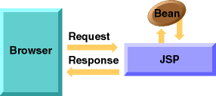

In this scenario, suppose the page accesses reusable Java Bean components that perform particular well-defined computations like accessing a database. The results of the Bean’s computations, called result sets are stored with in the Bean as properties. The page uses such Beans to generate dynamic content and present it back to the client.

1. A request comes through a servlet.

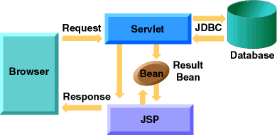

The servlet generates the dynamic content. To handle the response to the client, the servlet creates a Bean and stores the dynamic content (sometimes called the *result set*) in the Bean. The servlet then invokes a Java Server Page that will present the content along with the Bean containing the generated from the servlet.

There are two APIs to support this model of request processing using Java Server Pages. One API facilitates passing context between the invoking servlet and the Java Server Page. The other API lets the invoking servlet specify which Java Server Page to use. In both of the above cases, the page could also contain any valid Java code. The Java Server Pages architecture encourages separation of content from presentation--it does not mandate it.

How to Choose Between Access Models

With at least two access models, the question naturally arises "When does it make sense to have a Java Server Page as the front-end to a servlet, as the back-end to a servlet, or use only the servlet? Here are some possible guidelines:

* If a graphical interface (GUI) is necessary to collect the request data--use a Java Server Pages file.
* If the request and request parameters are otherwise available to the servlet, but the results of the servlet processing requires a graphical interface to present them--use a Java Server Pages file.
* If presentation layout is minimal (will not require very many println lines in your servlet code) and you don't need to make that presentation logic available to a customer or your web page designer, then a Servlet might suffice.

**WAP**

WAP is a protocol, a data transport mechanism. In many ways it is similar to HTTP (the protocol the web uses for data transport), and was built based on established standards, such as IP, URLs and XML. Since WAP was designed for wireless computing it has to accommodate the unique and fundamental limitations of wireless computing such as:

* Devices with limited processing power and memory
* Limited battery life and power
* Small displays
* Limited data input and user interaction capabilities
* Limited bandwidth and connection speeds
* Frequent unstable connections

WAP Specification

The key components of WAP specification are:

* A programming model based heavily on the existing Web programming model
* An XML-conforming markup language designed for creating device-independent WAP applications
* The WMLScript scripting language based on European computer Manufactures Association ECMAScript language for extending the power of WML.
* A microbrowser specification that defines how WML and WMLScript should be interpreted in the handset and presented to the user
* A framework for wireless telephony applications (WTA), providing functions that carrier can use to integrate the telephone and microbrowser functions of a WAP device
* A lightweight protocol stack designed to minimize bandwidth requirements, work with a variety of wireless transports, and provide secure connections.

**Java Technology**

Initially the language was called as “oak” but it was renamed as “Java” in 1995. The primary motivation of this language was the need for a platform-independent (i.e., architecture neutral) language that could be used to create software to be embedded in various consumer electronic devices.

* Java is a programmer’s language.
* Java is cohesive and consistent.
* Except for those constraints imposed by the Internet environment, Java gives the programmer, full control.
* Finally, Java is to Internet programming where C was to system programming.

**Importance of Java to the Internet**

Java has had a profound effect on the Internet. This is because; Java expands the Universe of objects that can move about freely in Cyberspace. In a network, two categories of objects are transmitted between the Server and the Personal computer. They are: Passive information and Dynamic active programs. The Dynamic, Self-executing programs cause serious problems in the areas of Security and probability. But, Java addresses those concerns and by doing so, has opened the door to an exciting new form of program called the Applet.

**Java can be used to create two types of programs**

Applications and Applets: An application is a program that runs on our Computer under the operating system of that computer. It is more or less like one creating using C or C++. Java’s ability to create Applets makes it important. An Applet is an application designed to be transmitted over the Internet and executed by a Java –compatible web browser. An applet is actually a tiny Java program, dynamically downloaded across the network, just like an image. But the difference is, it is an intelligent program, not just a media file. It can react to the user input and dynamically change.

**Features of Java Security**

Every time you that you download a “normal” program, you are risking a viral infection. Prior to Java, most users did not download executable programs frequently, and those who did scan them for viruses prior to execution. Most users still worried about the possibility of infecting their systems with a virus. In addition, another type of malicious program exists that must be guarded against. This type of program can gather private information, such as credit card numbers, bank account balances, and passwords. Java answers both these concerns by providing a “firewall” between a network application and your computer. When you use a Java-compatible Web browser, you can safely download Java applets without fear of virus infection or malicious intent.

**Portability**

For programs to be dynamically downloaded to all the various types of platforms connected to the Internet, some means of generating portable executable code is needed .As you will see, the same mechanism that helps ensure security also helps create portability. Indeed, Java’s solution to these two problems is both elegant and efficient.

**The Byte code**

The key that allows the Java to solve the security and portability problems is that the output of Java compiler is Byte code. Byte code is a highly optimized set of instructions designed to be executed by the Java run-time system, which is called the Java Virtual Machine (JVM). That is, in its standard form, the JVM is an interpreter for byte code.

Translating a Java program into byte code helps makes it much easier to run a program in a wide variety of environments. The reason is, once the run-time package exists for a given system, any Java program can run on it.

Although Java was designed for interpretation, there is technically nothing about Java that prevents on-the-fly compilation of byte code into native code. Sun has just completed its Just In Time (JIT) compiler for byte code. When the JIT compiler is a part of JVM, it compiles byte code into executable code in real time, on a piece-by-piece, demand basis. It is not possible to compile an entire Java program into executable code all at once, because Java performs various run-time checks that can be done only at run time. The JIT compiles code, as it is needed, during execution.

**Java Virtual Machine (JVM)**

Beyond the language, there is the Java virtual machine. The Java virtual machine is an important element of the Java technology. The virtual machine can be embedded within a web browser or an operating system. Once a piece of Java code is loaded onto a machine, it is verified. As part of the loading process, a class loader is invoked and does byte code verification makes sure that the code that’s has been generated by the compiler will not corrupt the machine that it’s loaded on. Byte code verification takes place at the end of the compilation process to make sure that is all accurate and correct. So byte code verification is integral to the compiling and executing of Java code.

Overall Description

Java Source

Java byte code

JavaVM

Java

.Class

Picture showing the development process of JAVA Program

Java programming uses to produce byte codes and executes them. The first box indicates that the Java source code is located in a. Java file that is processed with a Java compiler called javac. The Java compiler produces a file called a. class file, which contains the byte code. The .Class file is then loaded across the network or loaded locally on your machine into the execution environment is the Java virtual machine, which interprets and executes the byte code.

**Java Architecture**

Java architecture provides a portable, robust, high performing environment for development. Java provides portability by compiling the byte codes for the Java Virtual Machine, which is then interpreted on each platform by the run-time environment. Java is a dynamic system, able to load code when needed from a machine in the same room or across the planet.

**Compilation of code**

When you compile the code, the Java compiler creates machine code (called byte code) for a hypothetical machine called Java Virtual Machine (JVM). The JVM is supposed to execute the byte code. The JVM is created for overcoming the issue of portability. The code is written and compiled for one machine and interpreted on all machines. This machine is called Java Virtual Machine.

**INTRODUCTION TO MYSQL**

**MySQL**

MySQL (http://www.mysql.com) is a robust SQL database server developed and maintained by T.c.X DataKonsultAB of Stockholm, Sweden. Publically available since 1995, MySQL has risen to become one of the most popular database servers in the world, this popularity due in part to the server’s speed, robustness, and

flexible licensing policy. (See note for more information regarding MySQL’s licensing strategy.)

Given the merits of MySQL’s characteristics, coupled with a vast and extremely easy-to-use set of predefined interfacing functions, MySQL has arguably become PHP’s most-popular database counterpart.

**Installation**

MySQL is so popular among PHP users that support for the db server is automatically built into the PHP distribution. Therefore, the only task that you are left to deal with is the proper installation of the MySQL package. MySQL is compatible with practically every major operating system, including, among others, FreeBSD, Solaris, UNIX, Linux, and the various Windows versions. While the licensing policy is considerably more flexible than that of other database servers, I strongly suggest taking some time to read through the licensing information found at the MySQL site (<http://www.mysql.com>).

You can download the latest version of MySQL from one of the many worldwide mirrors. A complete listing of these mirrors is at http://www.mysql.com/ downloads/mirrors.html. At the time of this writing the latest stable version of MySQL was 3.22.32, with version 3.23 in beta. It is in your best interest to always download the latest stable version. Go to the mirror closest to you and download the version that corresponds with your operating system platform. You’ll see links at the top of the page pointing to the most recent versions. Be sure to read through the entire page, as several OS-specific downloads are at the conclusion. The MySQL development team has done a great job putting together extensive documentation regarding the installation process.

**Configuring MySQL**

After a successful installation, it is time to configure the MySQL server. This process largely consists of creating new databases and configuring the MySQL *privilege* *tables.* The privilege tables control the MySQL database access permissions. Correct configuration of these tables is pivotal to securing your database system, and therefore it is imperative that you fully understand the details of the privilege system before launching your site into a production environment. Although a chore to learn at first, the MySQL privilege tables are extremely easy to maintain once you understand them. A complete introduction to these tables is certainly out of the scope of this book. However, a number of resources available on the Web are geared toward bringing MySQL users up to speed. Check out the MySQL site (http://www.mysql.com) for further information. Once you have correctly installed and configured the MySQL distribution, it’s time to begin experimenting with Web-based databasing! The next section turns our attention towards exactly this matter, starting with an introduction of PHP’s MySQL functionality.

**PHP’s Predefined MySQL Functions**

Once you have created and successfully tested the necessary permissions, you are ready to begin using the MySQL server. In this section, I introduce the predefined MySQL functions, enabling you to easily interface your PHP scripts with a MySQL server. Here is the general order of events that take place during the MySQL server

communications process: 1. Establish a connection with the MySQL server. If the connection attempt fails, display an appropriate message and exit process. 2. Select a database on the MySQL server. If you cannot select the database, display an appropriate message and exit process. It’s possible to simultaneously have several databases open for querying. 3. Perform necessary queries on selected database(s). 4. Once the querying is complete, close the database server connection. The example tables (products, customers, orders) in Figure 11-1 are used as the basis for the examples in the remainder of this section. If you would like to follow along with these examples, I suggest going back and creating them now. Alternatively, make a copy of the pages so you do not have to continuously flip back and forth. With that said, let’s begin at the beginning, that is, how to connect to the MySQL database server.

**mysql_connect()**

The function mysql_connect() is used to establish an initial connection with the MySQL server. Once a successful connection is established, a database residing on that server can be selected.

The syntax is:

int mysql_connect([string hostname [:port] [:/path/to/socket] [, string username] [, string password])

The hostname is the name of the host as listed in the MySQL server privilege tables. Of course, it is also used to direct the request to the Web server hosting the MySQL server, since it is possible to connect to a remote MySQL server. An optional *port* number can be included along with the host, in addition to an optional path to a socket when a local host is specified. Both the *username* and *password* input parameters should correspond to the username and password, respectively, as specified in the MySQL server privilege tables. Note that all of the input parameters are optional,

since the privilege tables can be loosely configured to accept a nonauthenticated connection. If the *hostname* parameter is empty, mysql_connect() attempts to connect to the local host.

An example connection call follows: @mysql_connect("localhost", "web", "4tf9zzzf") or die("Could not connect to MySQL server!"); In this case, localhost is the server host, web is the username, and 4tf9zzzf is the password. The @ preceding the mysql_connect() function will suppress any error message that results from a failed attempt, instead producing the custom one specified in the die() call. Note that no value is returned from the mysql_connect() call.

For example:

<?

$link1 = @mysql_connect("www.somehost.com", "web", "abcde") or die("Could not

connect to MySQL server!");

$link2 = @mysql_connect("www.someotherhost.com", "usr", "secret") or die("Could

not connect to MySQL server!");

?>

Now, $link1 and $link2 can be called as needed in subsequent queries. You will soon learn exactly how these link IDs are used in queries to specify the

intended server.

***mysql_select_db()***

Once a successful connection is established with the MySQL server, a database

residing on that server can be selected. This is accomplished with

mysql_select_db().

Its syntax is:

int mysql_select_db (string database_name [, int link_id])

*Databases*

267

NOTE The function mysql_pconnect() offers persistent connection support. In multiuser environments, mysql_pconnect() is recommended over mysql_connect() as a means for conserving system resources. The mysql_pconnect() input and return parameters are exactly the same as in mysql_connect().

The input parameter database_name should be selected and assigned an identification

handle (returned by mysql_select_db()). Note that the input parameter link_id is optional. This is true only when just a single MySQL server connection is open. When multiple connections are open, link_id must be specified. An example of how a database is selected using mysq(_select_db() follows:

<?

@mysql_connect("localhost", "web", "4tf9zzzf")

or die("Could not connect to MySQL server!");

@mysql_select_db("company") or die("Could not select company database!");

?>

If there is only one database selection, there is no need to return a database ID. However, as with mysql_connect(), when multiple databases are open, the database ID must be returned so there is a way to specify exactly which database you would like to perform a query on; otherwise the most recently *opened* link is used.

mysql_close()

Once you have finished querying the MySQL server, you should close the connection. The function mysql_close() will close the connection corresponding to the optional input parameter link_id. If the link_id input parameter is not specified, mysql_close() will close the most recently opened link. The syntax is:

int mysql_close ([int link_id])

An example of mysql_close() follows:

<?

@mysql_connect("localhost", "web", "4tf9zzzf")

or die("Could not connect to MySQL server!");

@mysql_select_db("company") or die("Could not select company database!");

print "You're connected to a MySQL database!";

mysql_close();

?>

In the above example, there is no need to specify a link identifier, since only

one open server connection exists when mysql_close() is called.

**mysql_query()**

The function mysql_query() provides the functional interface from which a database

can be queried.

Its syntax is:

int mysql_query (string query [, int link_id])

The input parameter query corresponds to an SQL query. This query is sent either to the server connection corresponding to the last opened link or to the connection specified by the optional input parameter link_id. People often mistakenly think that the mysql_query() function returns the results of the query. This is not the case. Depending on the type of query, mysql_query() has different outcomes. In a successful SELECT SQL statement, a result ID is returned that can subsequently be passed to mysql_result() so the selected data can be formatted and displayed to the screen. If the query fails, FALSE is returned. The function mysql_result() is introduced later in this section. Furthermore, the number of rows that have been selected can be determined by executing mysql_num_rows(). This function is also introduced later in this section. In the case of SQL statements involving INSERT, UPDATE, REPLACE, or DELETE, the function mysql_affected_rows() can be called to determine how many rows were affected by the query.

(The function mysql_affected_rows() is introduced next.) With that said, I will delay presenting an example until the mysql_result() and mysql_affected_rows() functions are introduced.

**mysql_affected_rows()**

It is often useful to return the number of rows affected by an SQL query involving

an INSERT, UPDATE, REPLACE, or DELETE. This is accomplished with the function

mysql_affected_rows(). Its syntax is:

int mysql_affected_rows ([int link_id])

**mysql_pconnect().**

TIP If you are concerned that you are using up too much memory when making various query calls, call the predefined PHP function mysql_free_result(). This function, which takes as input the result_id returned from mysql_query(), will free up all memory associated with that query call.

Notice that the input parameter link_id is optional. If it is not included, mysql_affected_rows() attempts to use the last opened link_id. Consider the following

example:

<?

// connect to the server and select a database.

@mysql_connect("localhost", "web", "4tf9zzzf")

or die("Could not connect to MySQL server!");

@mysql_select_db("company") or die("Could not select company database!");

// declare query

$query = "UPDATE products SET prod_name = \"cantaloupe\"

WHERE prod_id = \"1001pr\"";

// execute query

$result = mysql_query($query);

// determine the number of rows that have been affected.

print "Total row updated: ".mysql_affected_rows();

mysql_close();

?>

Executing this code example returns this:

Total rows updated: 1

This will not work for queries involving a SELECT statement. To determine the number of rows returned from a SELECT, use the function mysql_num_rows() instead. This function is introduced next.

**mysql_num_rows()**

The function mysql_num_rows() is used to determine the number of rows returned from a SELECT query statement.

its syntax is:

int mysql_num_rows (int result)

A usage example of mysql_num_rows() follows:

**mysql_result()**

The function mysql_result() is used in conjunction with mysql_query() (when a

SELECT query is involved) to produce a data set.

Its syntax is:

int mysql_result (int result_id, int row [, mixed field])

The input parameter result_id refers to a value returned by mysql_query().

The parameter row refers to a particular row in the dataset specified by the result_id. Lastly, the optional input parameter field can be used to specify the

Following:

• Field offset in the table.

• Field name

• Field name specified in dot format. Dot format is simply another way to specify the field name, specified as fieldname.tablename.

**4. SYSTEM DESIGN**

**4.1 ARCHITECTURE DESIGN**

**Home page**

**Trusted Authority**

**System public Key**

**Generate Attribute key**

**Generate private key**

**CSP**

**Generates re-encrypted cipher texts for users**

**Semi-trusted CSP and unauthorized users**

**Data Owner**

**Data Disseminator**

**Data Co-Owner**

**Data User**

**Chooses a random key**

**Encrypts data**

**Customize fine-grained**

**Tree-based dissemination conditions**

**4.2 DATA FLOW DIAGRAM**

Home Page

TA Login

Admin Login

Login Form

Approved Clients

View Approved Clients

Registration

Add User Attributes

Disseminates Files

View Users

Registration Form

Registration

User Attributes

A

Registration

File Accessors

Co-Owner Login

User Login

Owner Login

Upload Files

Co-owner Policies

A

View Co-owner Attributes

View Co-owner Attributes

View Co-owner Attributes

Add File Policies

View Download Users

View Files

Upload Files

Co-owner Policies

File Accessors

View My Details

Registration

File Accessor

View My Files

**4.3 ER DIAGRAM**

Registration

Uploads

Upload File

Allots

Co-Owner Files

Verifies

User Attributes

File Accessor

Allows

Send

Co-Owner Policies

Assigns

**4.4 DATA BASE DESIGN**

**Registration**

|  |  |
| --- | --- |
| **Field Name** | **Field Type** |
| Name | varchar(50) |
| Gender | varchar(15) |
| DOB | date |
| Age | int |
| Address | varchar(75) |
| MailId | varchar(50) |
| MobileNo | varchar(15) |
| Designation | varchar(50) |
| UserType | varchar(50) |
| UserId | varchar(50) |
| Password | varchar(50) |
| RegDate | date |
| Status | varchar(15) |
| SecretKey | varchar(18) |

**UserAttributes**

|  |  |
| --- | --- |
| **Field Name** | **Field Type** |
| UserId | varchar(50) |
| Technology | varchar(50) |
| Experience | varchar(50) |
| Domain | varchar(50) |
| Efficiency | varchar(50) |

**UploadFiles**

|  |  |
| --- | --- |
| **Field Name** | **Field Type** |
| FileId | int |
| FileName | varchar(50) |
| UserId | varchar(50) |
| UploadedDate | date |
| FileKey | varchar(50) |
| AccessPolicy | varchar(50) |

**Co_OwnerFile**

|  |  |
| --- | --- |
| **Field Name** | **Field Type** |
| FileId | int |
| Co_OwnerId | varchar(50) |

**Co_OwnerPolicies**

|  |  |
| --- | --- |
| **Field Name** | **Field Type** |
| FileId | int |
| Co_OwnerId | varchar(50) |
| Policy1 | varchar(50) |
| Policy2 | varchar(50) |
| Policy3 | varchar(50) |
| Policy4 | varchar(50) |

**FileAccessors**

|  |  |
| --- | --- |
| **Field Name** | **Field Type** |
| FileId | int |
| FileName | varchar(50) |
| FileKey | varchar(50) |
| DataAccessor | varchar(50) |

**5. SYSTEM IMPLEMENTATION**

Implementation is the stage in the project where the theoretical design is turned into a working system. The most critical stage is achieving a successful system and in giving confidence on the new system for the users, what it will work efficient and effectively. It involves careful planning, investing of the current system, and its constraints on implementation, design of methods to achieve the change over methods.

The implementation process begins with preparing a plan for the implementation of the system. According to this plan, the activities are to be carried out in these plans; discussion has been made regarding the equipment, resources and how to test activities.

The coding step translates a detail design representation into a programming language realization. Programming languages are vehicles for communication between human and computers programming language characteristics and coding style can profoundly affect software quality and maintainability. The coding is done with the following characteristics in mind.

* Ease of design to code translation.
* Code efficiency.
* Memory efficiency.
* Maintainability.

The user should be very careful while implementing a project to ensure what they have planned is properly implemented. The user should not change the purpose of project while implementing. The user should not go in a roundabout way to achieve a solution; it should be direct, crisp and clear and up to the point.

**6. SYSTEM TESTING**

System Testing is an important stage in any system development life cycle. Testing is a process of executing a program with the intention of finding errors. The importance of software testing and its implications with respect to software quality cannot be overemphasized. Software testing is a critical element of software quality assurance and represents the ultimate review of specification, design and coding. A good test case is one that has a high probability of finding a yet undiscovered error.

Testing is the set of activities that can be planned in advance and conducted systematically. Different test conditions should be thoroughly checked and the bugs detected should be fixed. The testing strategies formed by the user are performed to prove that the software is free and clear from errors. To do this, there are many ways of testing the system’s reliability, completeness and maintainability.

**Unit Testing**

In the unit testing the analyst tests the program making up a system. The software units in a system are the modules and routines that are assembled and integrated to perform a specific function. In a large system, many modules on different levels are needed.

Unit testing can be performed from the bottom up starting with the smallest and lowest level modules and proceeding one at a time. For each module in a bottom-up testing, a short program executes the module and provides the needed data.

**Integration Testing**

Integration testing is a systematic technique for constructing the program structure while conducting test to uncover errors associate with interfacing. Objectives are used to take unit test modules and built program structure that has been directed by design.

The integration testing is performed for this Project when all the modules where to make it a complete system. After integration the project works successfully.

**Validation Testing**

Validation testing can be defined in many ways, but a simple definition is that can be reasonably expected by the customer. After validation test has been conducted, one of two possible conditions exists.

* The functions or performance characteristics confirm to specification and are accepted.
* A deviation from specification is uncovered and a deficiency list is created.

Proposed system under consideration has been tested by using validation testing and found to be working satisfactorily.

For example, in this project validation testing is performed against user module. This module is tested with the following valid and invalid inputs for the field staff id.

**White Box Testing**

White box testing, sometimes called glass-box testing is a test case design method that uses the control structure of the procedural design to derive test cases. Using white box testing methods, the software engineer can derive test cases that

* Guarantee that all independent paths with in a module have been exercised at least once.
* Exercise all logical decisions on their true and false sides.
* Execute all loops at their boundaries and with in their operational bounds and
* Exercise internal data structure to assure their validity.

For example in this project white box testing is performed against patient module. Without entering text if we apply it displays the message “First add record then save it” else it should be saved.

**Black Box Testing**

This method treats the coded module as a black box. The module runs with inputs that are likely to cause errors. Then the output is checked to see if any error occurred. This method cannot be used to test all errors, because some errors may depend on the code or algorithm used to implement the module.

**7. SAMPLE INPUT AND OUTPUT**

**7.1 SOURCE CODE**

**7.2 SCREEN LAYOUT**

Home Page

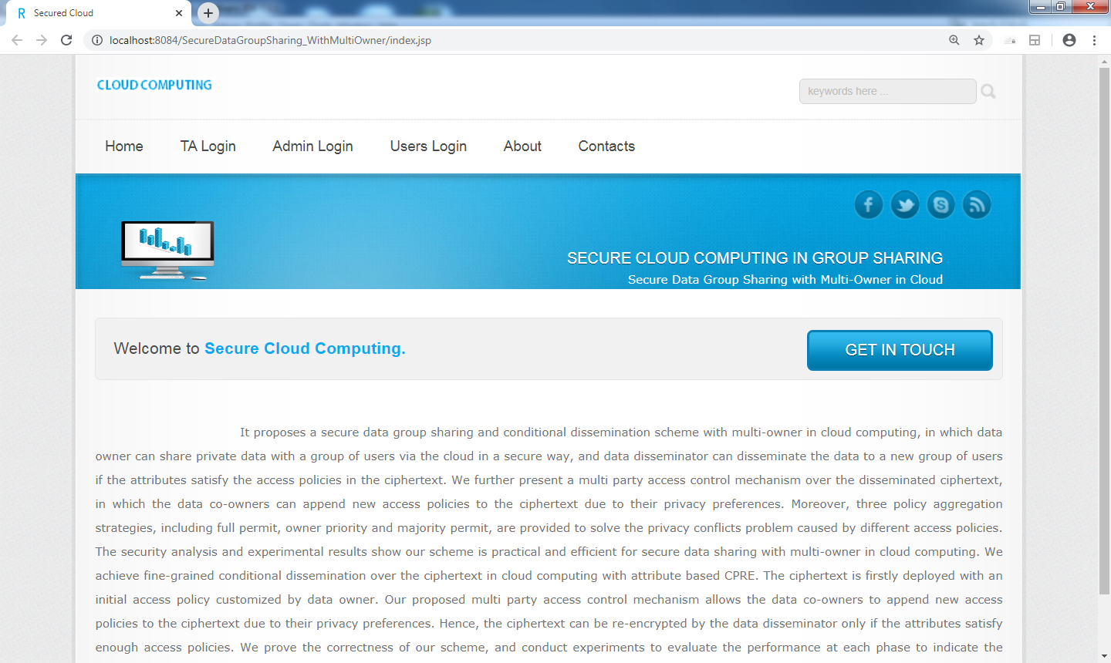

Admin Login

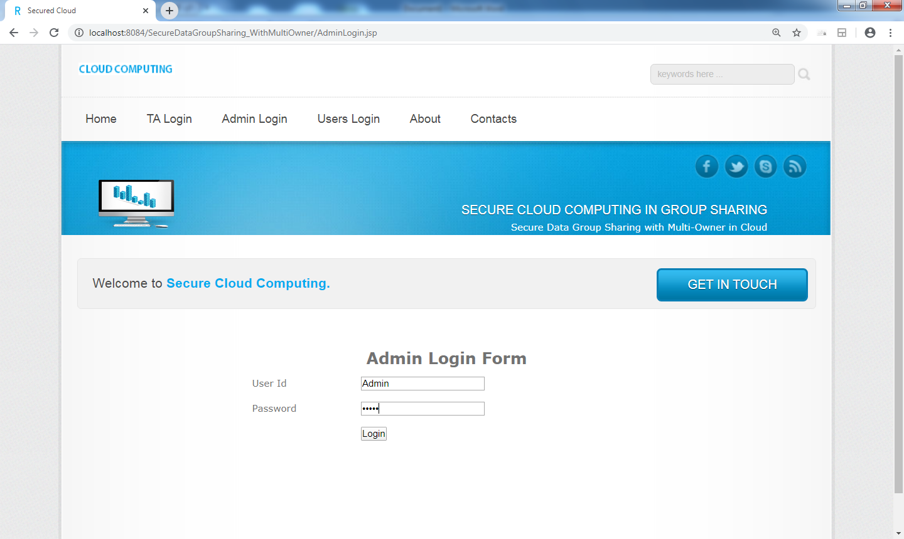

Admin Home

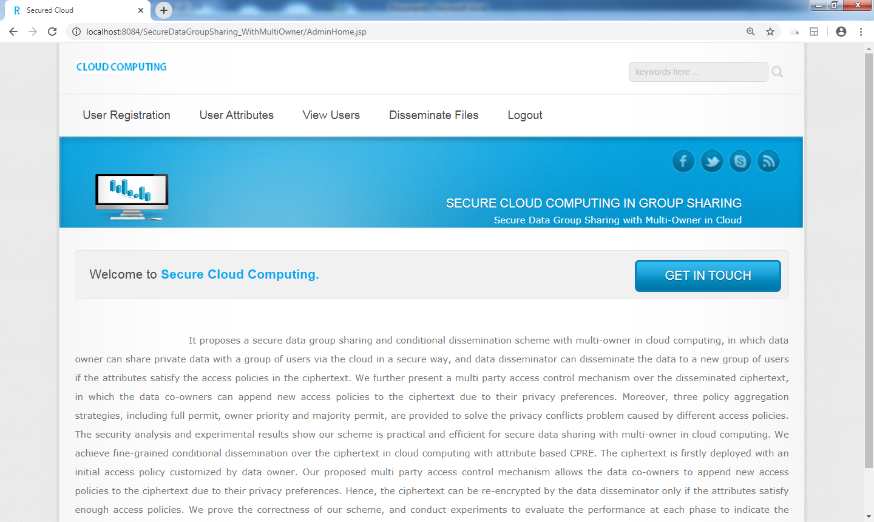

Registration Form

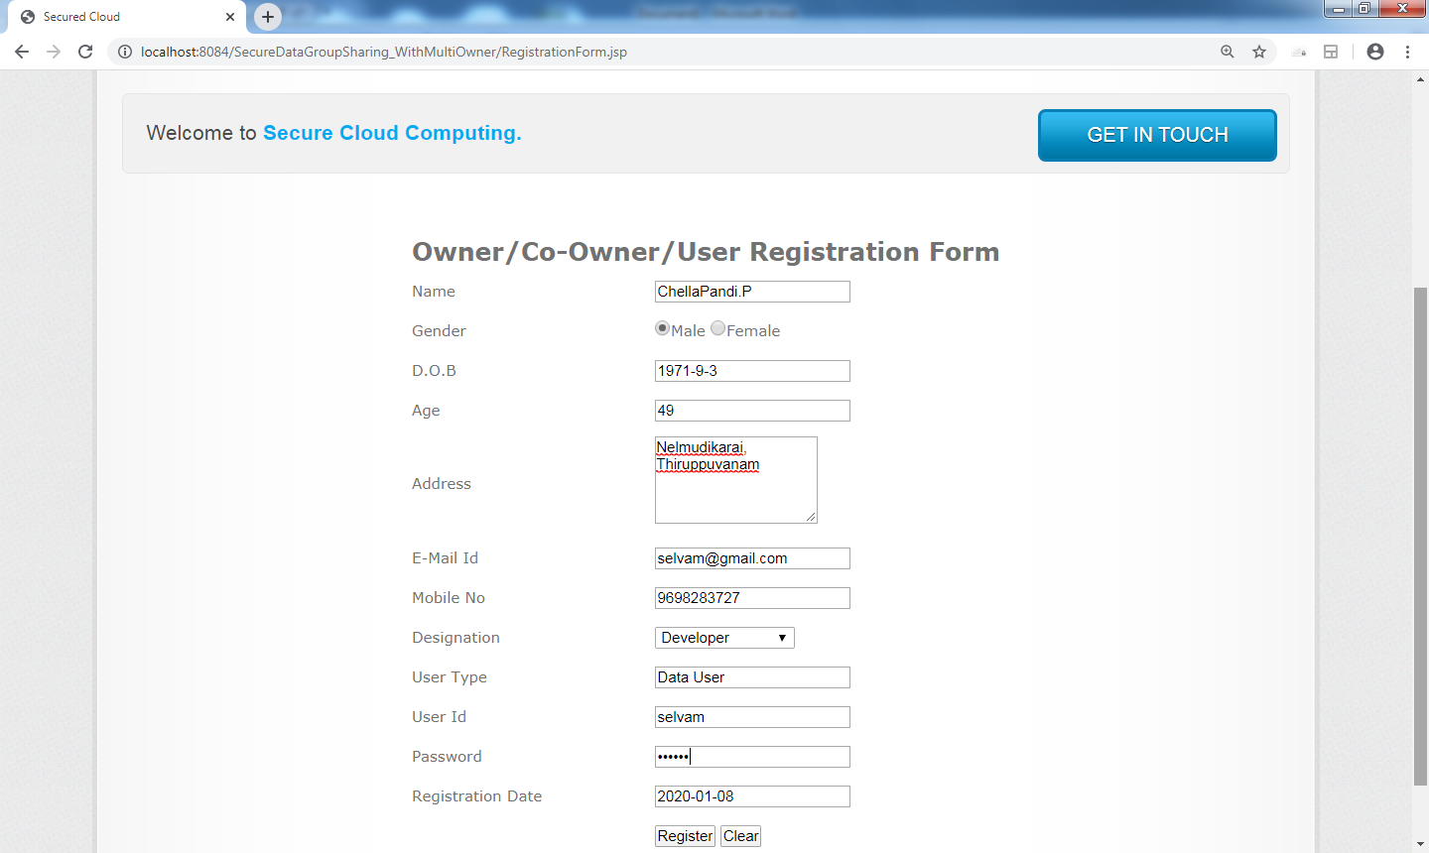

Register User Attributes

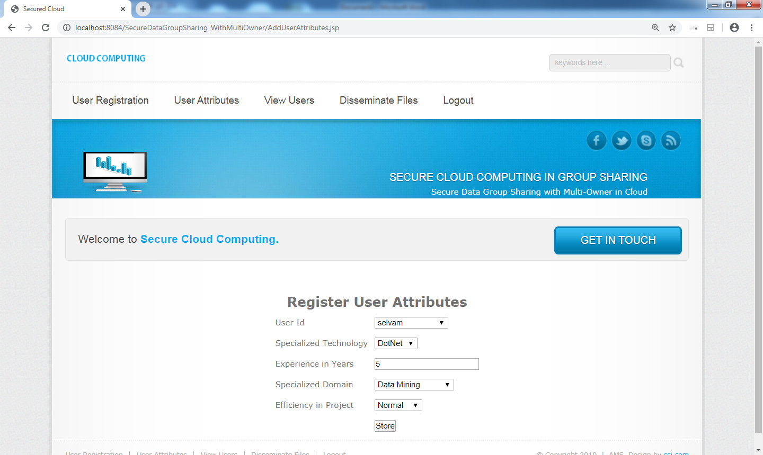

TPA Login

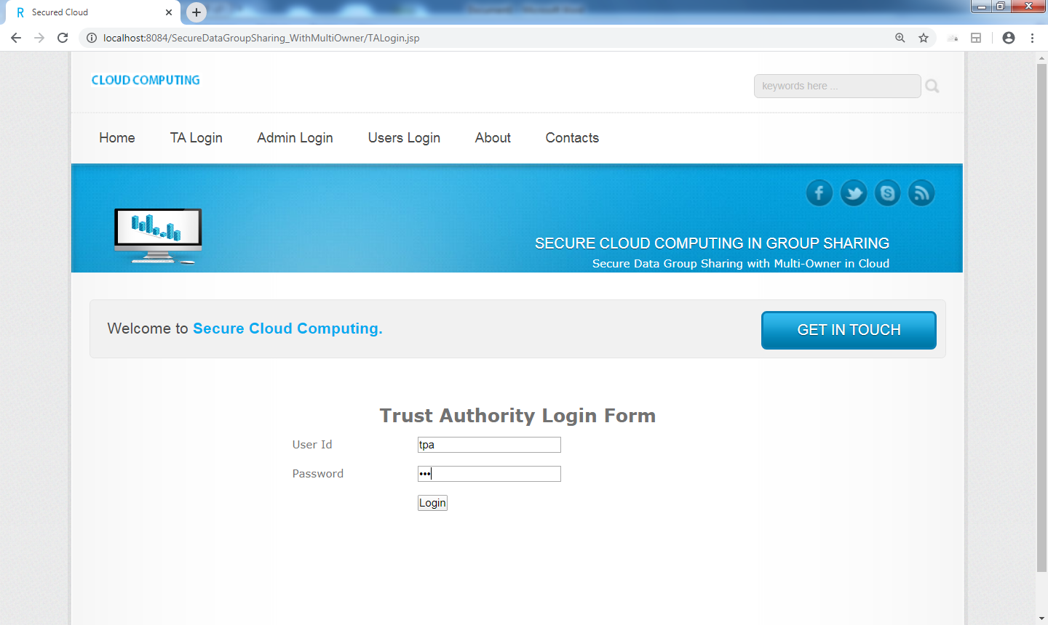

Pending Clients Info

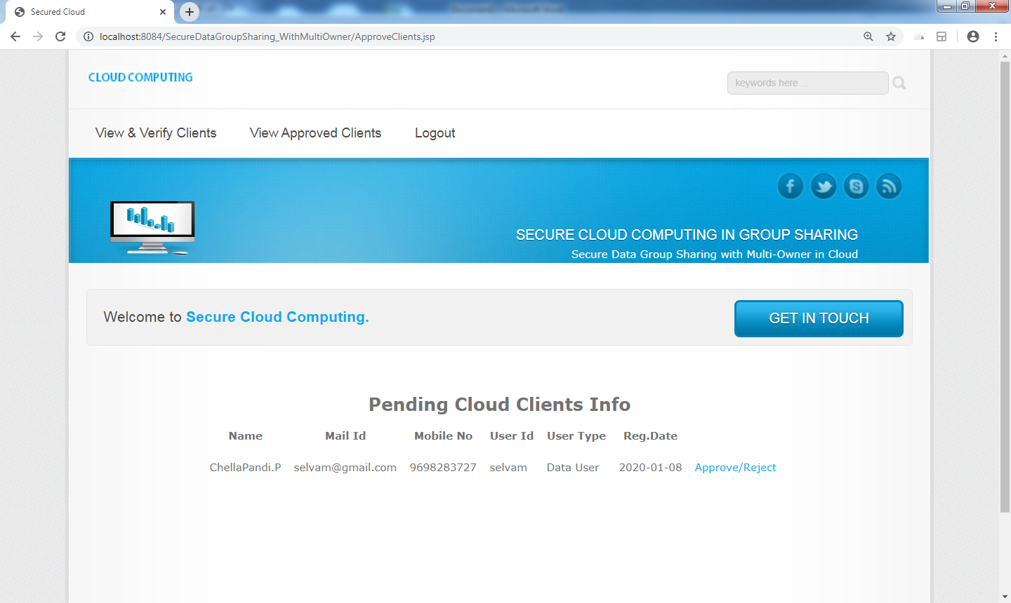

Update Client Status

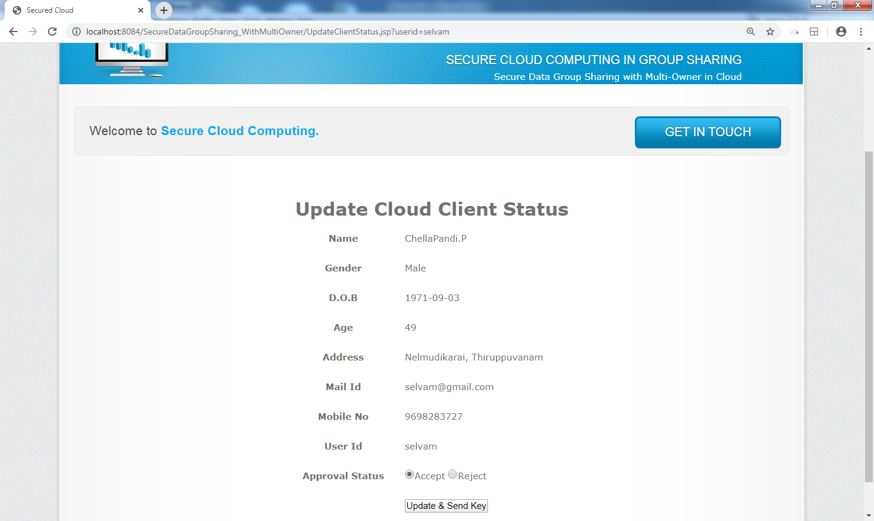

View Approved Clients by Admin

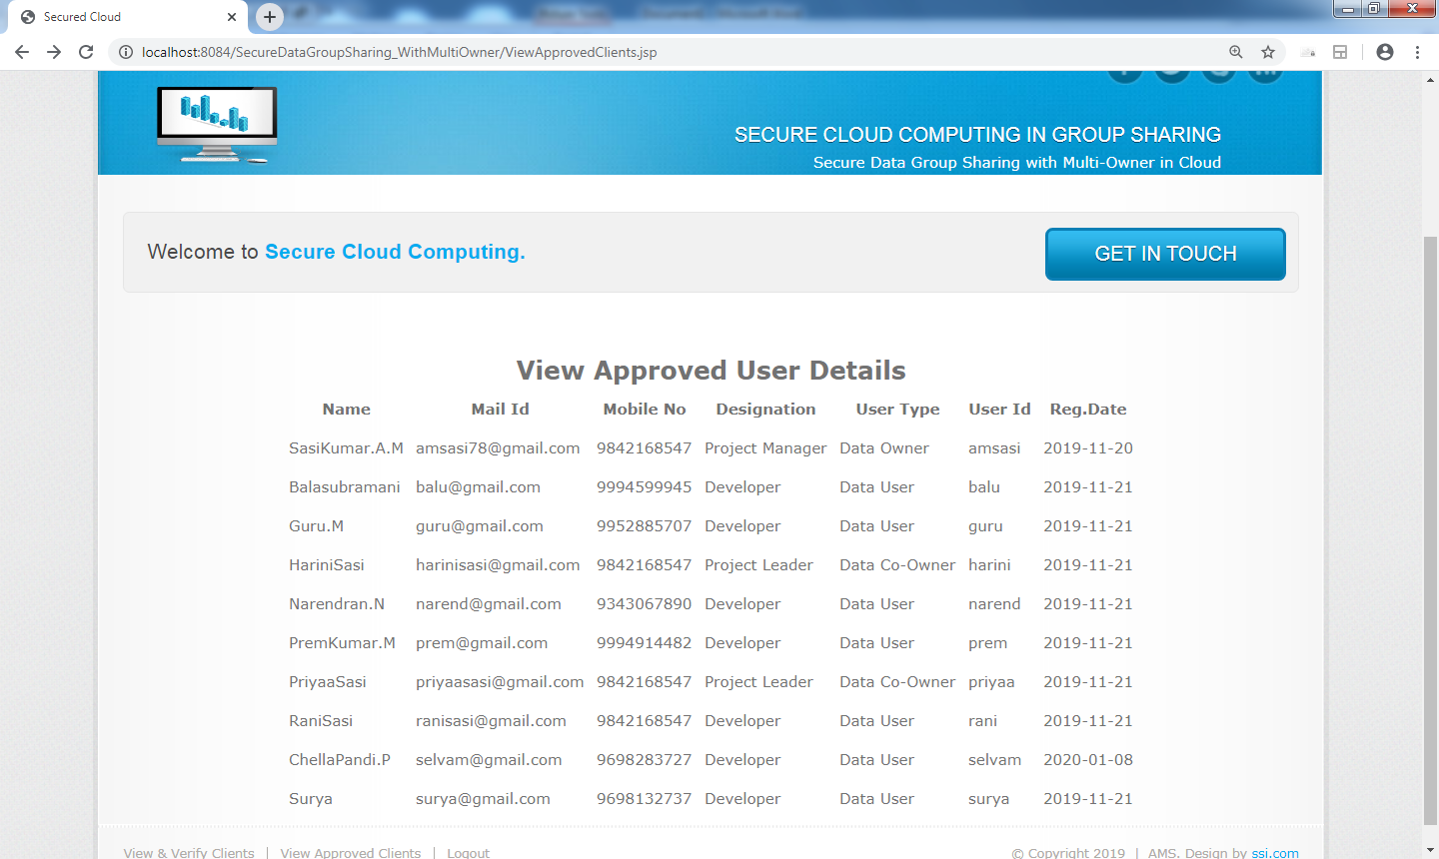

Login Form

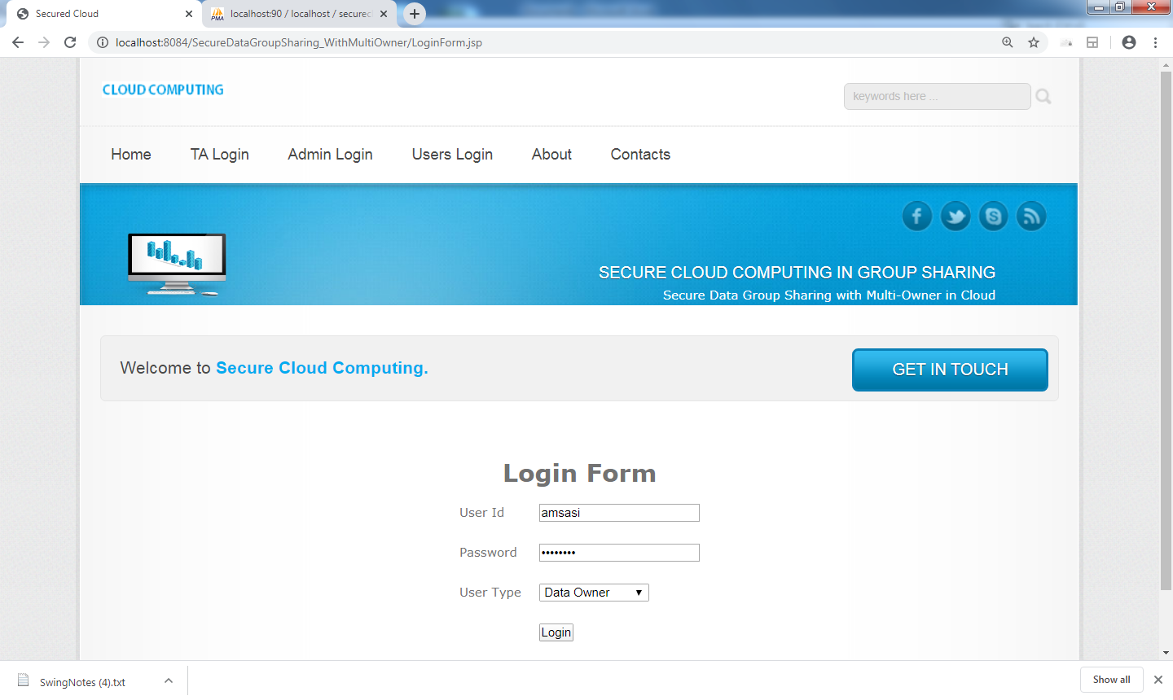

Client Secret Key Verification Form

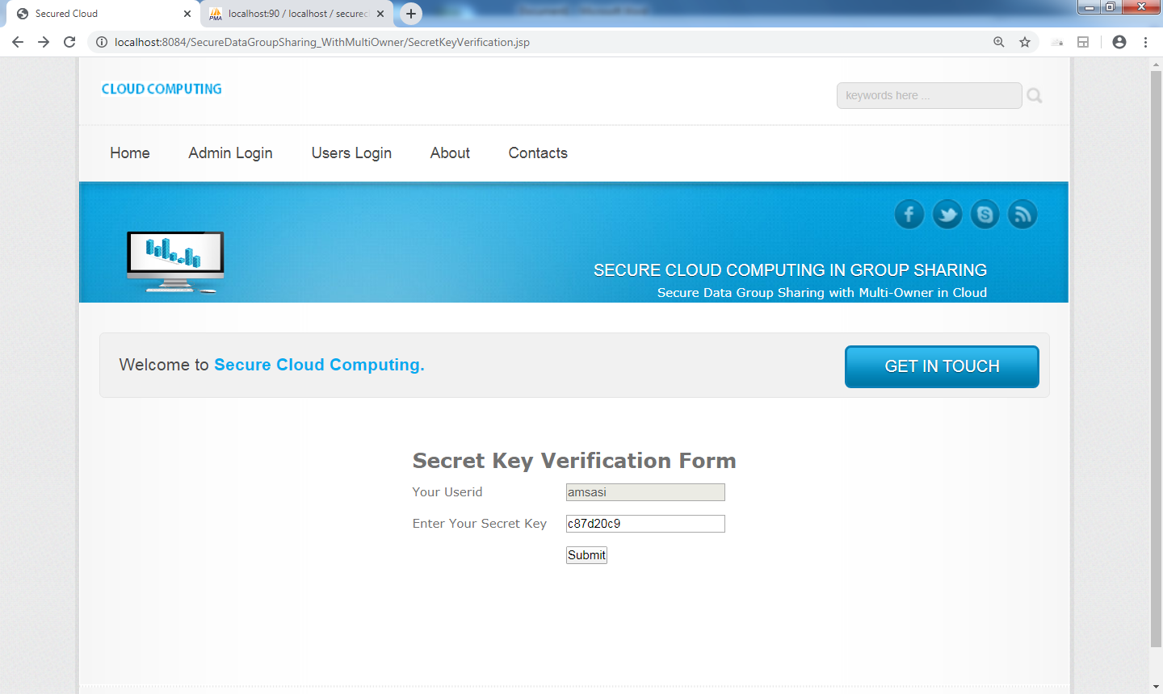

Upload File

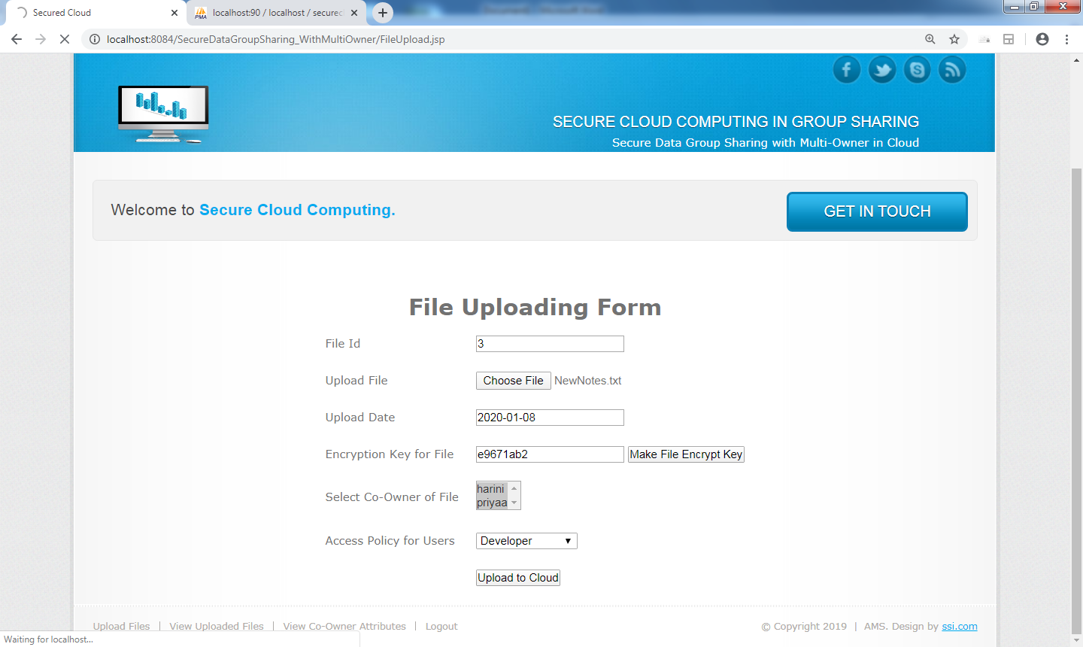

View Uploaded Files

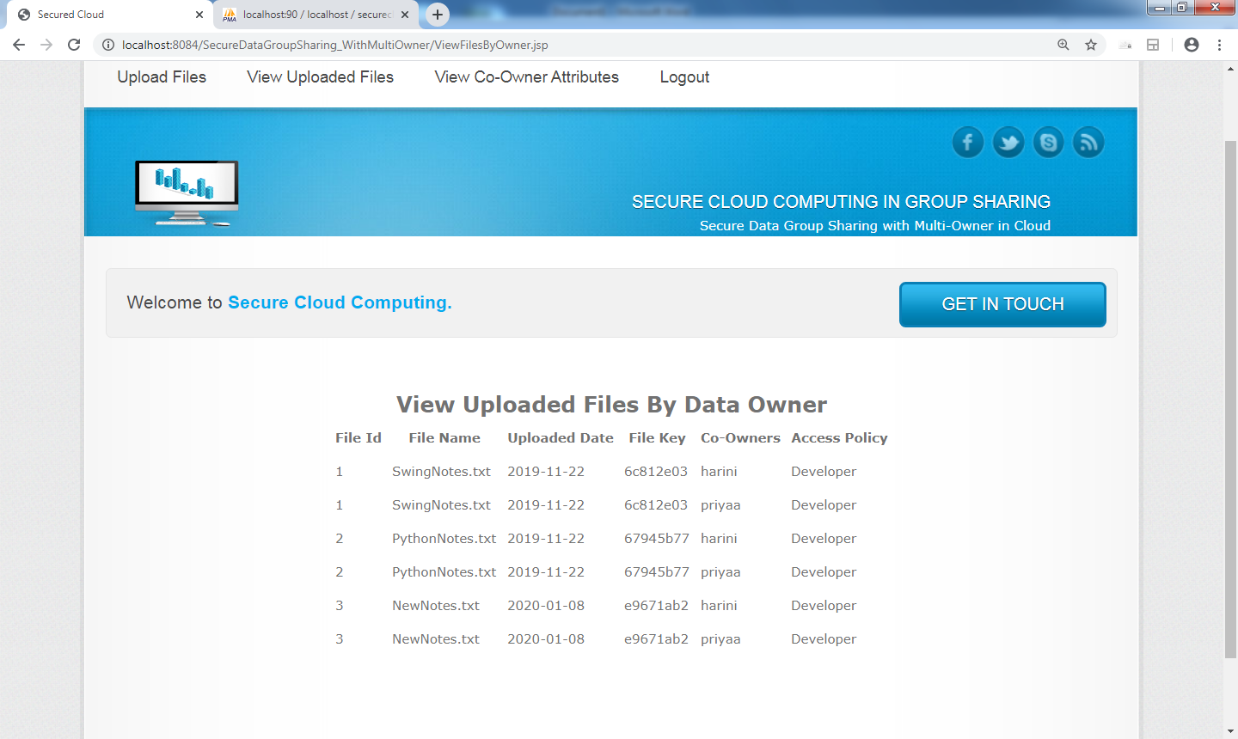

Data Owner Views Co-Owner Condition for the files

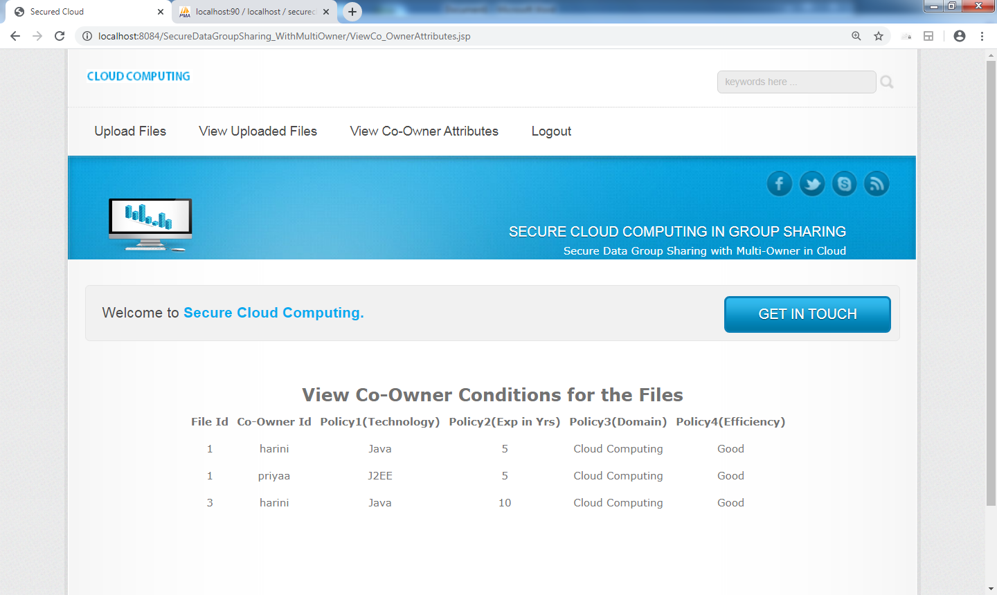

View Files by Co-Owner

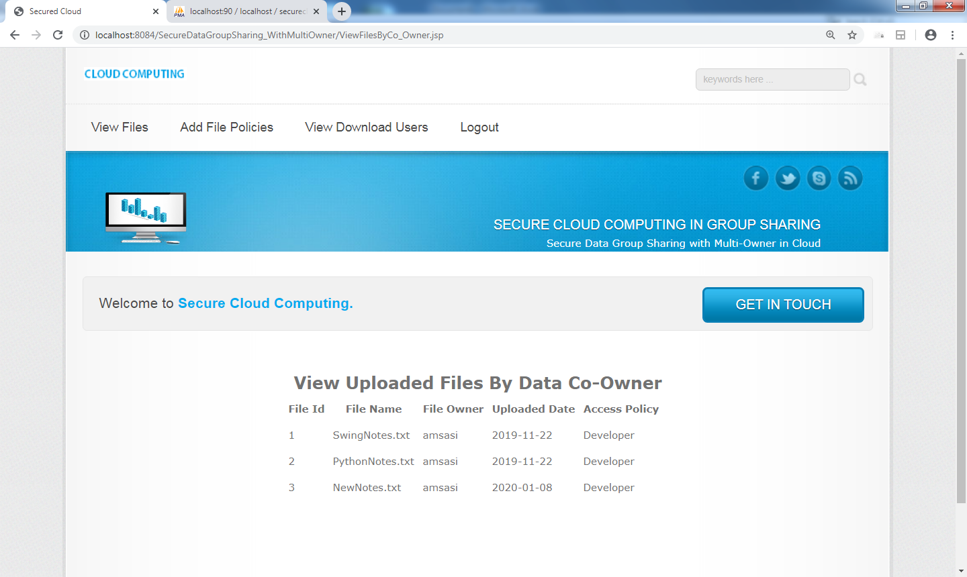

Add File Policies by Data Co-Owner

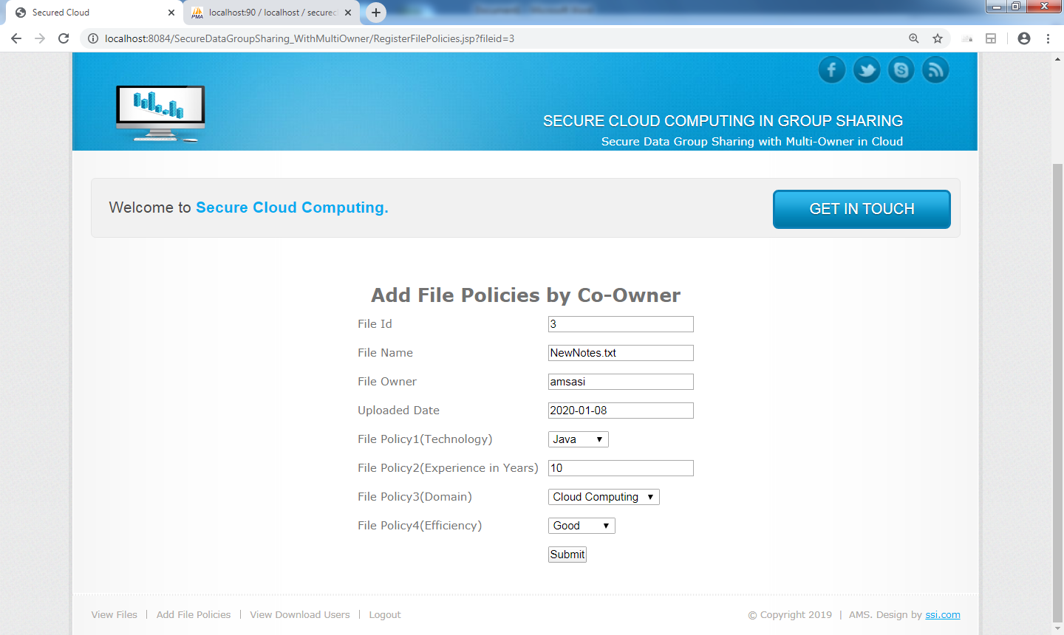

View Eligible Users to download files

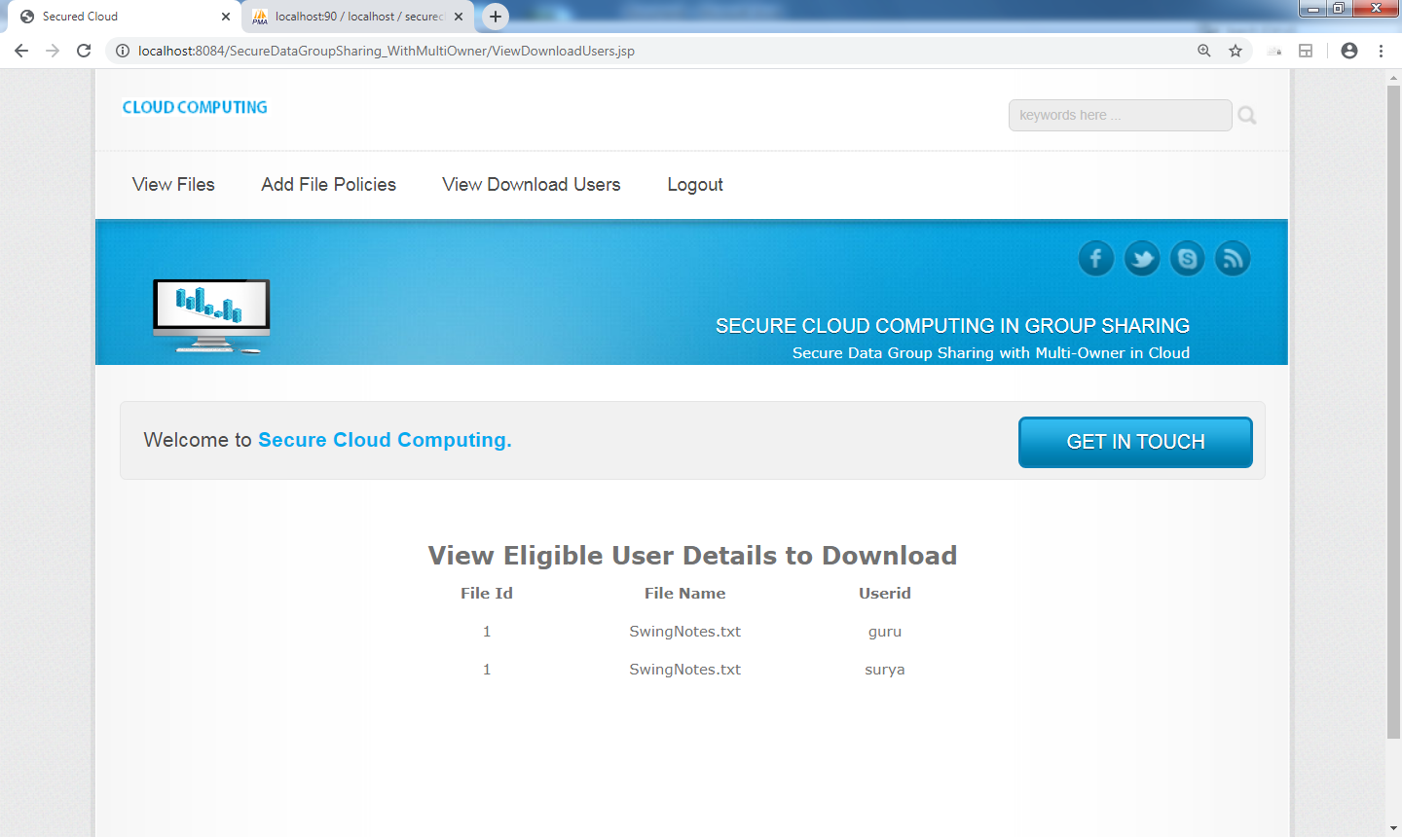

Disseminate files to eligible users by data disseminator (Admin)

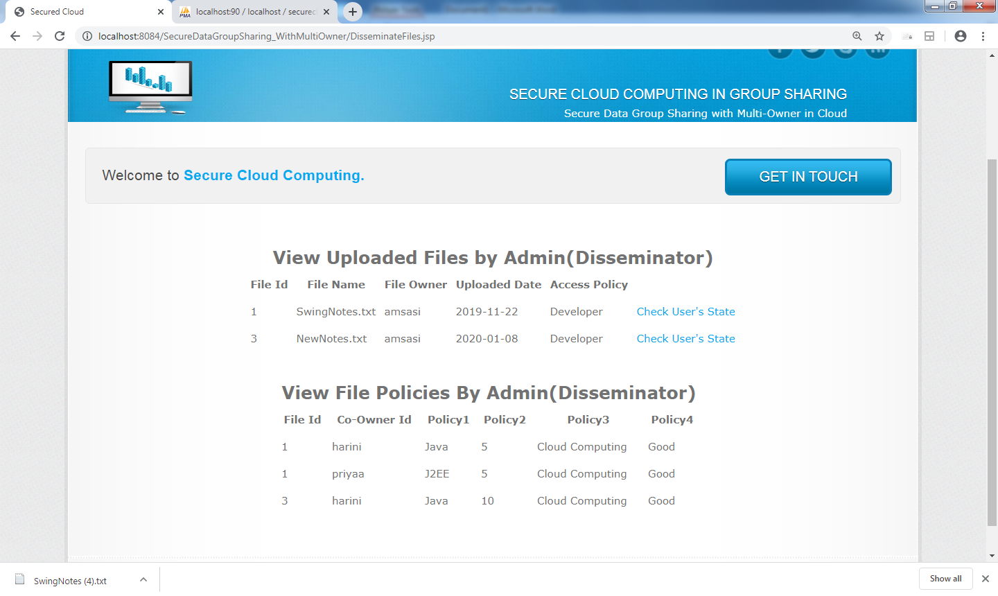

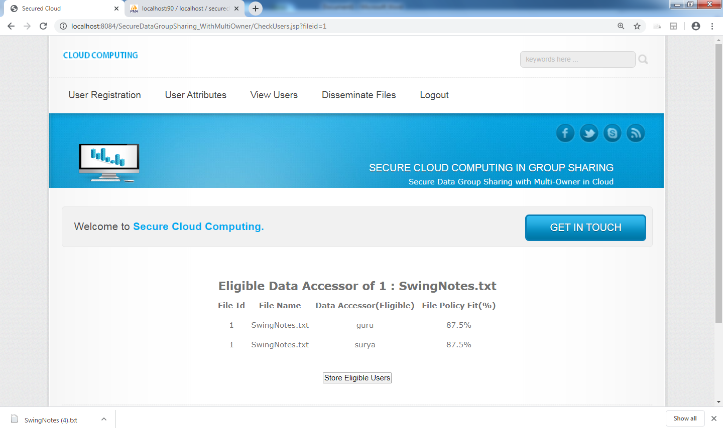

View User Account Info by himself

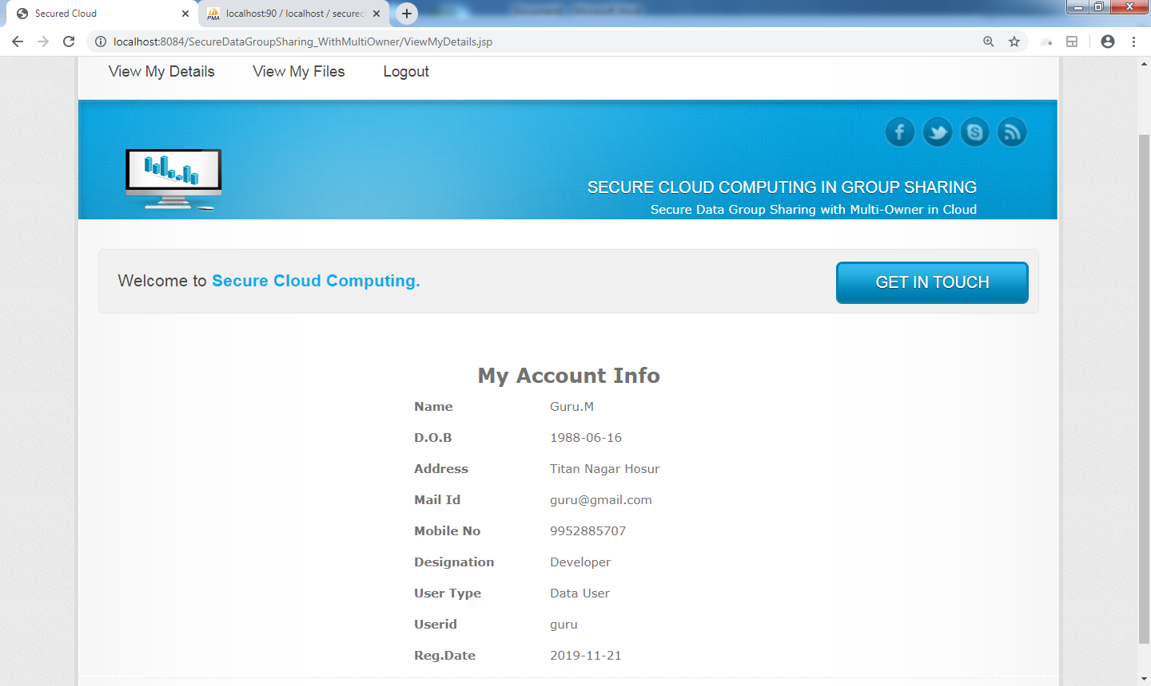

View Files by Data User

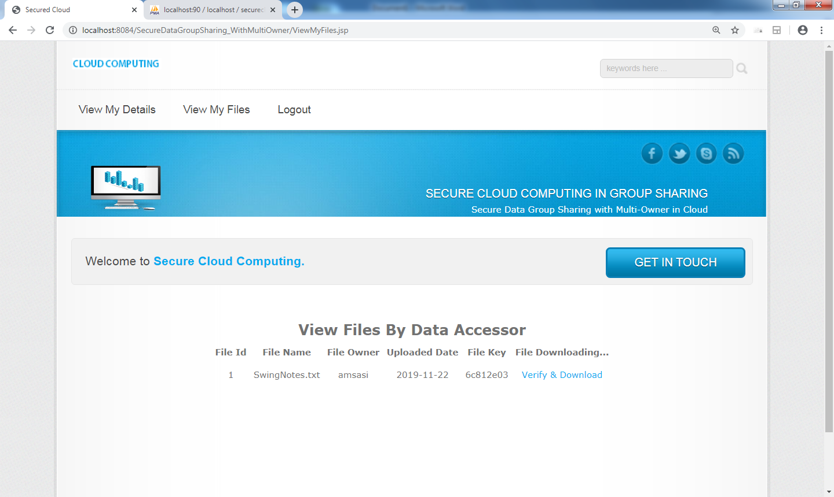

Key Verify & File download

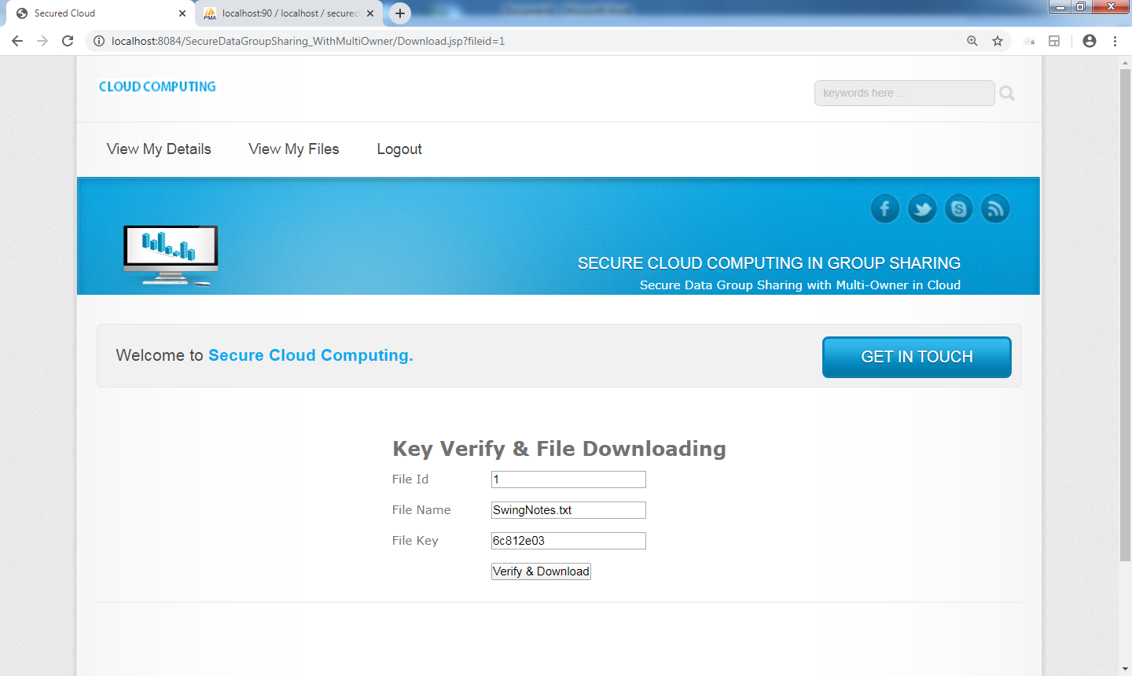

**8. FUTURE ENHANCEMENT**

We further present a multiparty access control mechanism over the ciphertext, which allows the data co-owners to append their access policies to the ciphertext. Besides, we provide three policy aggregation strategies including full permit, owner priority and majority permit to solve the problem of privacy conflicts. In the future, we will enhance our scheme by supporting keyword search over the ciphertext.

**9. CONCLUSION**

The data security and privacy is a concern for users in cloud computing. In particular, how to enforce privacy concerns of multiple owners and protect the data confidentiality becomes a challenge. In this paper, we present a secure data group sharing and conditional dissemination scheme with multi-owner in cloud computing. In our scheme, the data owner could encrypt her or his private data and share it with a group of data accessors at one time in a convenient way based on IBBE technique. Meanwhile, the data owner can specify fine-grained access policy to the ciphertext based on attribute-based CPRE, thus the ciphertext can only be re-encrypted by data disseminator whose attributes satisfy the access policy in the ciphertext.

**10. BIBLIOGRAPHY**

* B. Lang, J. Wang, and Y. Liu, “Achieving flexible and self-contained data protection in cloud computing,” IEEE Access, vol. 5, pp. 1510- 1523, 2017.
* Q. Zhang, L. T. Yang, and Z. Chen, “Privacy preserving deep computation model on cloud for big data feature learning,” IEEE Transactions on Computers, vol. 65, no. 5, pp. 1351-1362, 2016.
* H. Cui, X. Yi, and S. Nepal, “Achieving scalable access control over encrypted data for edge computing networks,” IEEE Access, vol. 6, pp. 30049–30059, 2018.
* K. Xue, W. Chen, W. Li, J. Hong, and P. Hong, “Combining data owner-side and cloud-side access control for encrypted cloud storage,” IEEE Transactions on Information Forensics and Security, vol. 13, no. 8, pp. 2062–2074, 2018.
* C. Delerablée, “Identity-based broadcast encryption with constant size ciphertexts and private keys,” Proc. International Conf. on the Theory and Application of Cryptology and Information Security (ASIACRYPT ‘2007), pp. 200-215, 2007.
* N. Paladi, C. Gehrmann, and A. Michalas, “Providing user security guarantees in public infrastructure clouds,” IEEE Transactions on Cloud Computing, vol. 5, no. 3, pp. 405-419, 2017.
* J. Bethencourt, A. Sahai, and B. Waters, “Ciphertext-policy attribute based encryption,” Proc. IEEE Symposium on Security and Privacy (SP ‘07), pp. 321-334, 2007.